HEAT AND MASS TRANSFER

**EXPERIMENT 3**

**Refrigeration System Model with Refrigeration and Deep Freeze Stage**

**Date: 6 / 09 / 2018**



Department of Mechanical Engineering

Indian Institute of Technology Kanpur

**Group – F4**

**Members:**

YASHASWI SINHA - 150841

VIPIN KUMAR - 150824

VIPUL RANJAN - 150810

VIVEK KUMAR SINGH -150806

**OBJECTIVE:** To learn the basics of refrigeration system

**THEORY** :Major components of a refrigeration system are evaporator, condenser, compressor and expansion valve. Evaporator is the space that needs to be cooled by the refrigerant. Compressor compresses the refrigerant from the low pressure of the evaporator to the pressure at the condenser. Heat gained by the refrigerant is rejected at the condenser and the high pressure refrigerant is expanded into low pressure evaporator through an expansion valve.

**EXPERIMENTAL SETUP:** Major components of a refrigeration system are evaporator, condenser, compressor and expansion valve. Evaporator is the space that needs to be cooled by the refrigerant. Compressor compresses the refrigerant from the low pressure of the evaporator to the pressure at the condenser. Heat gained by the refrigerant is rejected at the condenser and the high pressure refrigerant is expanded into low pressure evaporator through an expansion valve.

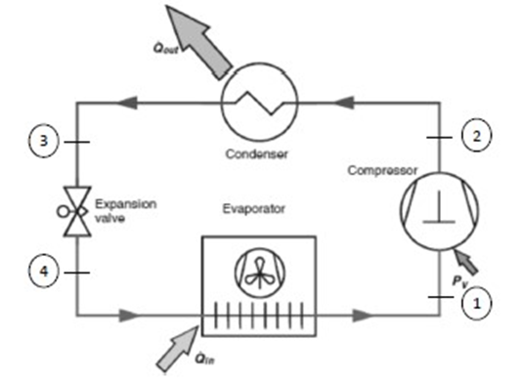

*Figure 1: Schematic representation of a simple vapour compression system*

**WORKING PRINCIPLE:** The fundamental principle of refrigerating circuit is its dependency of the boiling temperature on pressure. Heat absorption occurs at a lower temperature while heat emission at a higher temperature. In a compression refrigeration system, this is achieved by evaporating the refrigerant at a low temperature to withdraw desired amount of heat from the cooling chamber. To allow this, pressure is reduced so that the evaporation temperature is below the desired cooling chamber temperature. Evaporation corresponds to the line 4-1(Isobaric evaporation). During evaporation in the evaporator, refrigerant absorbs heat flow from the environment. The heat energy absorbed is released back to the environment. This is done by raising the refrigerant to a higher pressure level, at which the boiling temperature is above the ambient temperature. The heat flow absorbed is discharged back to the environment by condensation of the refrigerant in the condenser. This corresponds to the line 2-3(Isobaric condensation). Pressure increase from 1-2(Isentropic compression) is achieved using a compressor. An expansion valve is used for throttling 3-4(Isenthalpic regulation).

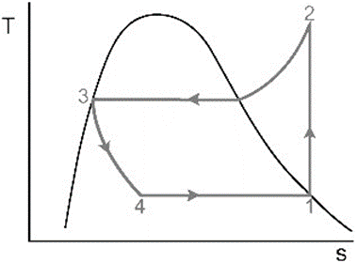

*Figure 2: T-S diagram*

**FORMULAE:**

* Specific Refrigeration Capacity

**q1= (h1-h4) kJ/kg**

* Specific compression work

**q2= (h2-h1) kJ/kg**

* Coefficient of performance of Carnot Process

**ε(c)=T1/(T2−T1)**

* Coefficient of performance of refrigeration system

**ε(𝑘)=q1⁄q2=(h1−h4)/(h2−h1)**

* Coefficient of performance of refrigeration system

**η=ε(k)/ε(c)**

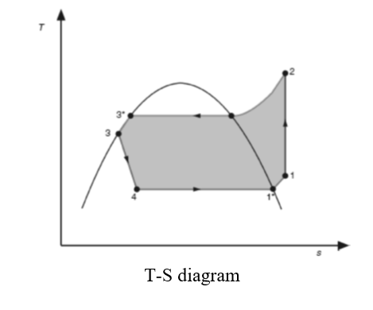

The changes of state plotted above have the following meaning here: 1-2: Isentropic compression 2-3: Isobaric condensation 3-4: Isenthalpic regulation 4-1: Isobaric evaporation 1*-1: Superheating 3*-3: Refrigerant supercooling

Superheating (1*-1) of the refrigerant: To prevent damage to a refrigeration system, it is necessary to superheat the refrigerant at the evaporator outlet. If the intake condition of the process were to lie directly on the condensation line, an incorrect evaporator load could cause “wet intake”, which could cause damage to the compressor. Superheating at the evaporator outlet prevents this. The superheating should be around 5K - 8K.

Supercooling (3*-3): The expansion valve is intended to throttle the refrigerant to a lower pressure level after condensation. To guarantee optimum functioning of this valve, pure liquid must be present at the valve inlet, which is ensured by prior supercooling of the liquid. In addition, refrigerant supercooling can be used to achieve a better system performance.

Refrigeration process (evaporator in parallel):

log p

-

h diagram (evaporator in

parallel

)

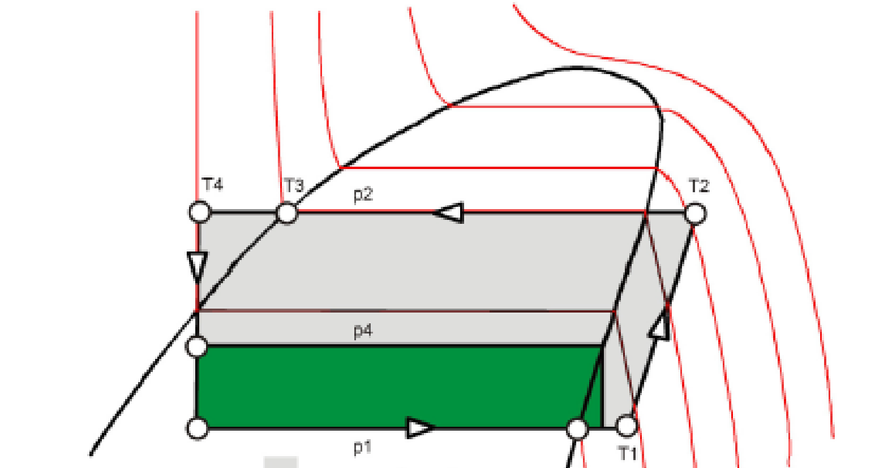

a

c

b

d

log p

h

In case of refrigeration process in which two evaporators are used in parallel configuration specific refrigeration capacity is sum of individual capacity of refrigerator:

*q1= 𝑞𝑎𝑏𝑑 +𝑞𝑐𝑑 kJ/kg*

Coefficient of performance of refrigeration system:

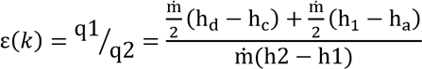

Refrigeration process (evaporator in series):



In case of refrigeration process in which two evaporators are used in series configuration specific refrigeration capacity is

*q1= (h1-h4) kJ/kg*

**RESULTS AND DISCUSSIONS**

* Single evaporator (with load):

Specific refrigeration capacity = (h1-h4) kJ/kg = 162.1

Specific compression work = (h2-h1) kJ/kg = 12.3

Coefficient of performance of Carnot Process = T1/(T2−T1) = 10.16

Coefficient of performance of refrigeration system = (h1−h4)/(h2−h1) =13.18

Performance factor of refrigeration system relative to carnot process = ε(k)/ε(c) = 1.29

* Single evaporator (without load):

Specific refrigeration capacity = (h1-h4) kJ/kg = 153.3

Specific compression work = (h2-h1) kJ/kg = 13.8

Coefficient of performance of Carnot Process = T1/(T2−T1) = 12

Coefficient of performance of refrigeration system = (h1−h4)/(h2−h1) =11.11

Performance factor of refrigeration system relative to carnot process = ε(k)/ε(c) = 0.92

* Evaporators in series (with load):

Specific refrigeration capacity = (h1-h4) kJ/kg = 71.8

Specific compression work = (h2-h1) kJ/kg =12.8

Coefficient of performance of Carnot Process = T1/(T2−T1) = 10.8

Coefficient of performance of refrigeration system = (h1−h4)/(h2−h1) = 13.48

Performance factor of refrigeration system relative to carnot process = ε(k)/ε(c) =1.24

* Evaporators in series (without load):

Specific refrigeration capacity = (h1-h4) kJ/kg = 169.8

Specific compression work = (h2-h1) kJ/kg =11.4

Coefficient of performance of Carnot Process = T1/(T2−T1) = 11.46

Coefficient of performance of refrigeration system = (h1−h4)/(h2−h1) = 14.89

Performance factor of refrigeration system relative to carnot process = ε(k)/ε(c) = 1.29

* Evaporator in parallel (with load):

Specific refrigeration capacity = (h1-h4) kJ/kg = 161.5

Specific compression work = (h2-h1) kJ/kg =25.4

Coefficient of performance of Carnot Process = T1/(T2−T1) = 7.5

Coefficient of performance of refrigeration system = (h1−h4)/(h2−h1) = 6.35

Performance factor of refrigeration system relative to carnot process = ε(k)/ε(c) =0.85

* Evaporator in parallel (without load):

Specific refrigeration capacity = (h1-h4) kJ/kg = 163.1

Specific compression work = (h2-h1) kJ/kg =21.6

Coefficient of performance of Carnot Process = T1/(T2−T1) = 8.2

Coefficient of performance of refrigeration system = (h1−h4)/(h2−h1) = 7.55

Performance factor of refrigeration system relative to carnot process = ε(k)/ε(c) = 0.92

Q>**Describe the effects of a cooling load on a cyclic process?**

* The coefficient of performance of carnot process decreases with load in every case.
* The performance factor relative to carnot process decreases when load is applied in case of parallel and series ( and should have decreased in the case of single evaporator too but this may be the reason of less time given for the system to come in steady state).
* The COP of refrigeration system decreases for parallel and series loads with the application of load because of the subcooling that occurs due to load.

**Conclusion:**

* A discrepancy in the value was noted and the reason might be the lack of time given to reach the steady condition.
* While plotting the cyclic graph, one could have seen a minor disparity in observed Temperature data and theoretical Temperature data. There would be errors in the readings as there are irreversibility associated with the system.